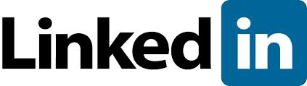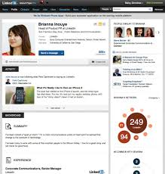
Did you know that according to a 2011 Microsoft Study 85% of employers say online reputation influences hiring decisions? Also, 70% of employers polled have rejected applicants because of information they found online.
What is LinkedIn
- It is a Professional Network (unlike Facebook which is more of a social network).
- There are over 200 million members currently signed-up.
- There are over 1 million groups and over 2 million business pages currently signed-up.
- There is no cost to sign-up and use most of the features.
Why is it worthwhile for me as a job seeker
- It has a huge network of professionals you can connect to.
- It is a great forum for discussions with people in your field.
- It is great for job hunting due to the large amount of jobs posted.
- It is great for researching information about companies.
- It is great for developing your reputation and personal brand.
Why you need an individual profile
A clear well developed complete profile is a must in this age of on line job searching. Incomplete profiles are all over LinkedIn and they do nothing for you. It also increases your odds of showing up in searches that recruiters and hiring managers often conduct on perspective candidates. This is because, if you choose to, your LinkedIn profile shows up as a link with your name on search engines such as Google.
Your Resume Services can show you how to use LinkedIn and help create a dynamic profile for you. It’s even easier when you have an existing resume.
Call 516-383-6630 for more information.
Go to LinkedIn.com now and sign up for a free account to check it out!

